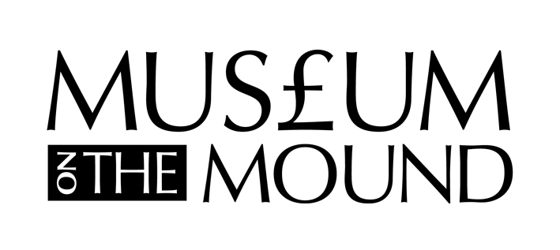
School Visits - Evaluation Form

Name of group leader: Date of visit:

Name of school:

Tel no: E-mail:

Number of pupils: Class:

1. What sort of experience did the children have at the Museum? Please highlight:

UNSATISFACTORY | SATISFACTORY | GOOD | VERY GOOD | EXCELLENT

2. How did your visit relate to your class study, and which were the most relevant parts?

3. What was the least successful part of your visit and why?

Following your visit to the museum, do you agree the children have: -

 |  | Strongly Disagree | Disagree | Neither Agree or Disagree | Agree | Strongly Agree
4 | Increased awareness of the value of money
5 | More confidence when handling money
6 | Greater understanding of the importance of saving
7 | Better appreciation of and respect for other cultures
8 | Improved confidence when expressing ideas

9. What else do you think the children gained from their visit to the museum?

10. What follow-up work will you do at school?

11. Please add any other comments about your visit.

12. Would you be willing to provide images of pupils work, e.g. for use on our website, for presentations to teachers or display purposes? YES/NO

13. Would you visit the Museum again? YES/NO

14. Would you recommend the Museum to other teachers? YES/NO

15. Would you like to be added to our mailing list? YES/NO

Thank you very much for your time. We hope to see you again.

The information provided on this form will be used solely by the Museum on the Mound to help us improve our education service. Your contact details will not be made available to any other party.
We may use some comments to market the Museum's schools service. If you would prefer not to be quoted, please tick this box:

Please return to:
Museum on the Mound, Lloyds Banking Group, The Mound, Edinburgh, EH1 1YZ
Or, email to info@museumonthemound.com
An electronic version will be sent to your contact email address.

